**SUNSET PARK FOOD COOP CAMPAIGN**

## Creative Brief

**Team Members:**

* Ziwei Xing
* Dimi Wu
* Darriel Bleasdille

**Campaign Name:**

Sunset Park Food Cooperative

**What is the purpose of this campaign?***What problem is this campaign helping to solve?*

* Promote the idea of the food-coop to the neighbor’s.
* Advertising cheap and organic foods to the neighbor’s.
* Make people join us.
* Our main purpose is not only to enable people in all communities to get cheap and healthy food, but to connect different ethnic groups in the community.

Here in the city a dedicated circle of enthusiasts who gladly work their monthly shifts in exchange for food that’s healthy, organic, sustainable, locally grown, and ethically manufactured has embraced them.

**Audience Profile***: Profile the target audience. Provide enough detail to enhance everyone’s understanding of who the audience is. Include some audience demographic information. Why would this audience care about the cause of your campaign?*

The audience is the neighborhoods who live near the Sunset Park, Brooklyn. Because our campaign is about food coop. Person could get food easier and the food is health and cheaper. It is close in proximity the neighbors would not have to travel far to purchase some delicious organic foods.

**Call for Action***: How should your target audience respond to your campaign? What do you want the audience to do?*

Our audiences are people who care about eating healthy foods and someone who wants to join this society in the Sunset Park Community.

We want audience could recommend our food coop to their friends and neighbor that make everyone know us. We also want our audience can join us and enjoy the new activity in the neighborhood.

**Communication Strategy***: What is the overall message you are trying to convey to your target audience? Why is this an important message? Describe the methods you will use to convey the overall message.*

We share responsibilities and benefits equally. We strive to be a responsible and ethical employer and neighbor. We offer a diversity of products with an emphasis on organic, minimally processed and healthful foods.

**Perception & Tone*:****What adjectives can be used to describe the way the campaign should be perceived by the target audience? What is the personality and style that we want to convey?*

* **Tone:**

Responsive / Creative / Clearly / Friendly

* **Style:**

Modern / Tradition / Fancy

**Deliverables***: What are the suggested deliverables or formats? What are the key milestones/dates to include in the schedule?*

* Video
* Poster
* Website

**How will success be defined and how will it be measured?***How will What mechanisms will be used to measure responses?*

Chinese, Jewish, and Hispanic people are the most populous group of people in the community. The location of our food coops will be at the junction of the three ethnic blocks. This is near the 7th Avenue 50th Street. Our standard of success is to be able to attract different people from different ethnic group. Here, they will be able to come together, buy the food they need and meet new people. This will promote harmony within the community. We strive to be convenient, by providing healthy foods with cheap prices.

**Competitive Positioning:***How is your campaign different from its competition and what are the factors that will make it a success?*

Here in the city a dedicated circle of enthusiasts who gladly work their monthly shifts in exchange for food that’s healthy, organic, sustainable, locally grown, and ethically manufactured has embraced them.

Today, Sunset Park's population is composed of Hispanics, Chinese, Jewish, Indians and Norwegians. In this diverse community, the different ethnic groups keep amongst themselves and their respectful tradition activities. In the Sunset Park community, there are very few activities that attract all the people to participate in same event. This creates a lack of connection. Sunset Park Food Coops attracts people from the community to participate in this event at a low price and fun event program. Promote the relationship between peoples in a cooperative manner.

**Source of Materials:** *Are there any existing materials? (text, imagery, video, etc. Include links and attachments.) What will be the source of imagery, text, video and other source materials?*

**What additional information would be helpful for creative team?**

## Campaign Design Specs

**SLOGAN:**

HEALTH IS WEALTH

**Overall visual style:**

Sunset Park Food Coop undertake a very traditional-like visual style.

**Logo**

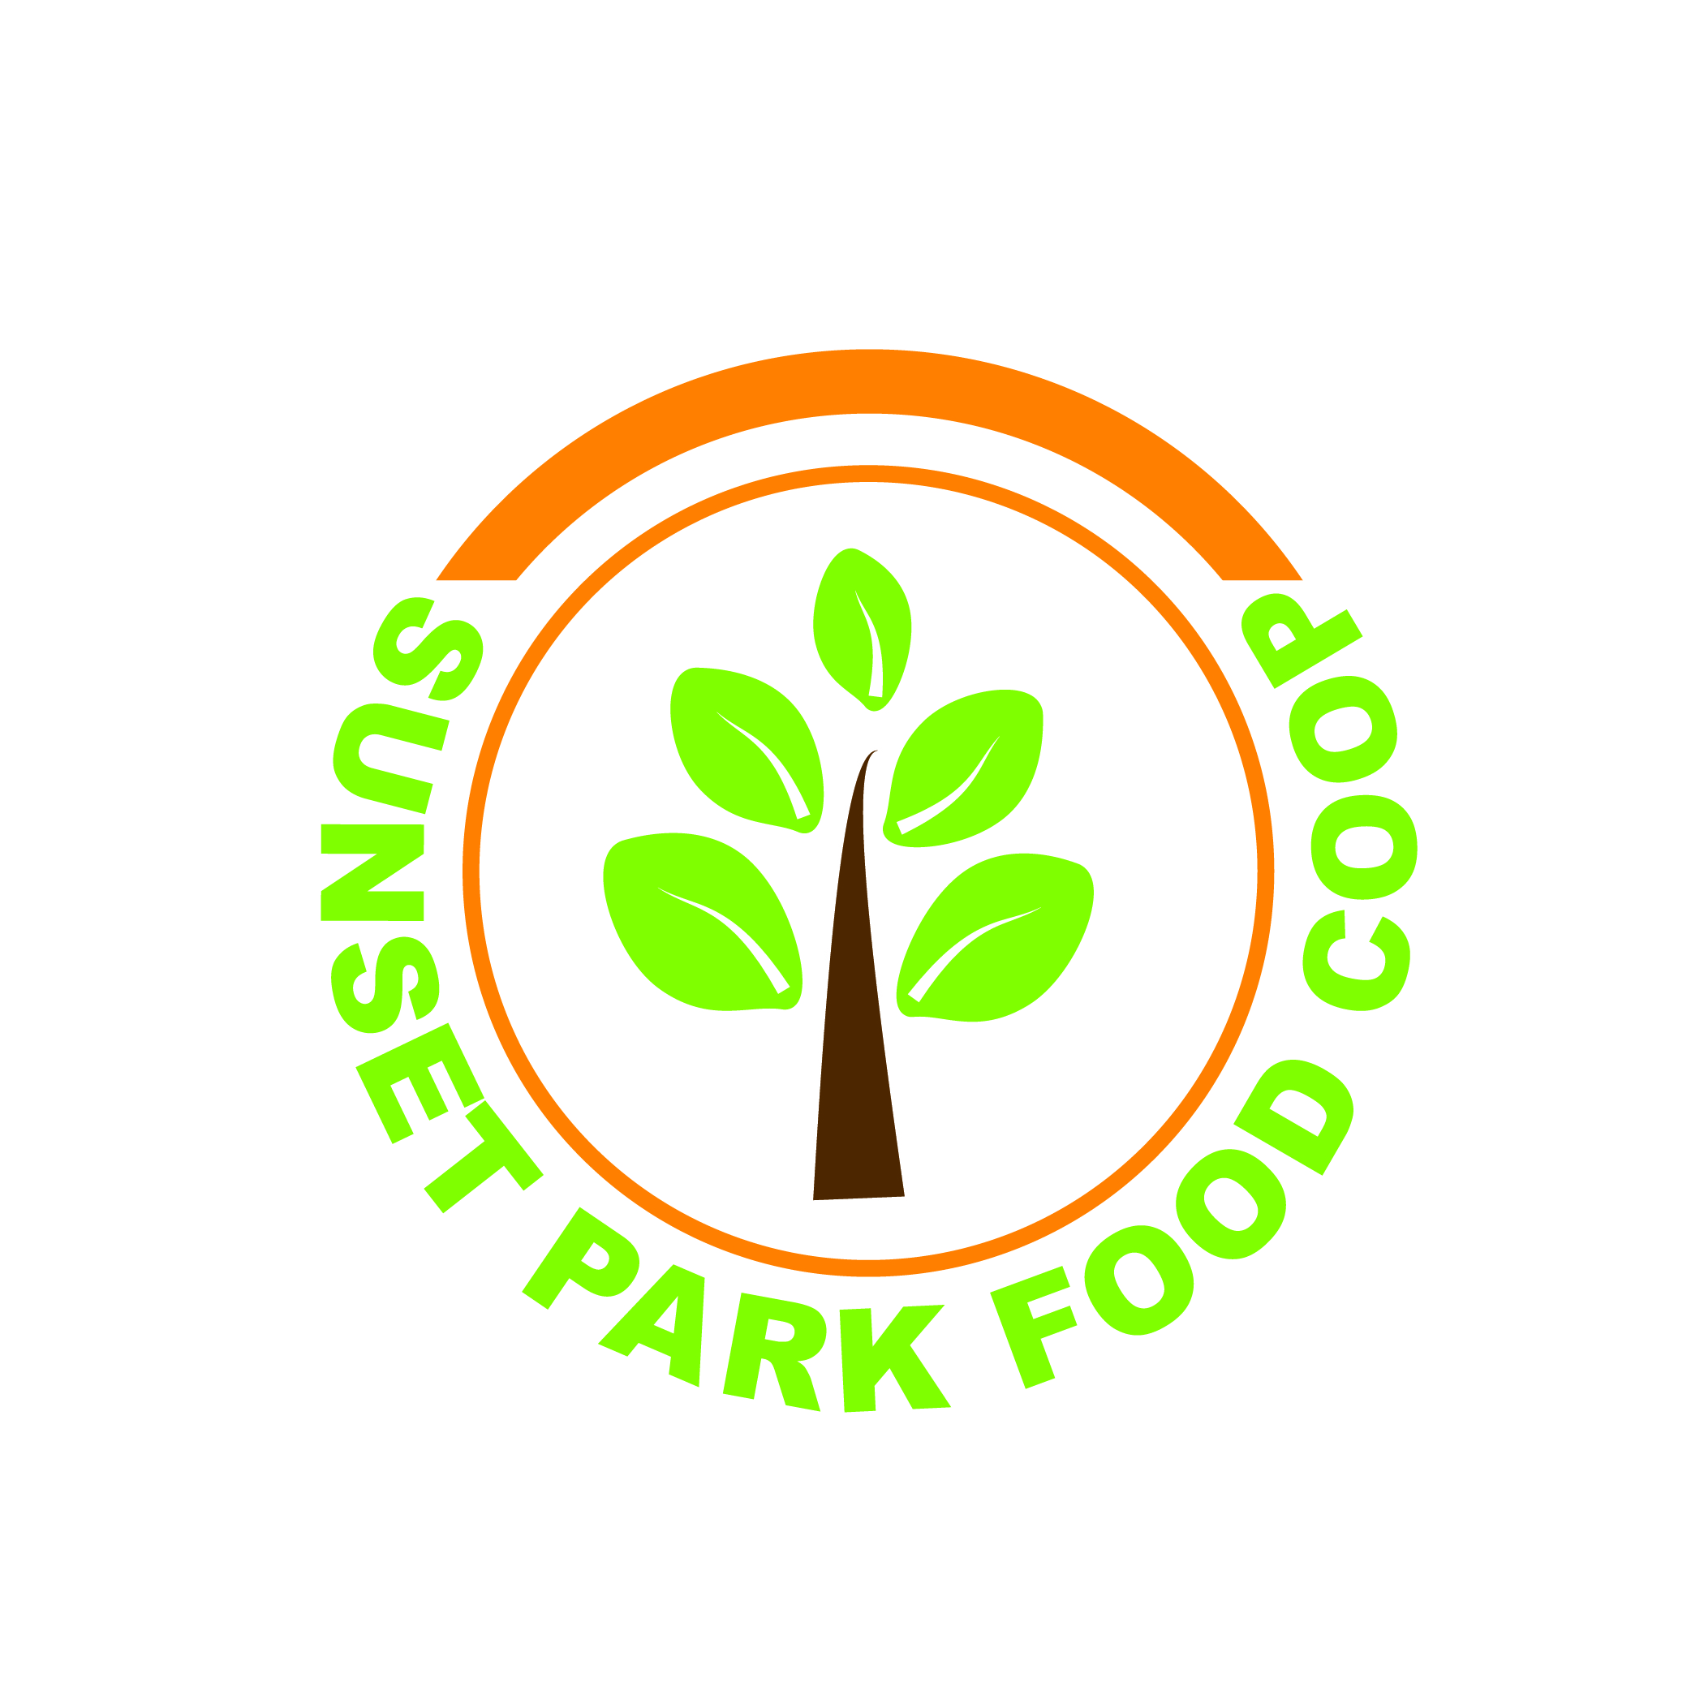

**Typography**

Fonts: Myriad Pro

Text type(body text): PT Sans

Font Weight:

Display text:38

body text: 25

Website:

Font: PTSansCaptionRegular, arial, helveica, sans-serif;

Display text: PTSansCaptionRegular, arial, helveica, sans-serif;

Font Weight: Bold, 600

Size:

Tittle: 2.5em

Header : 4 em, 30px

**Colors**

Green: #3f9034

Orange: #f17e07

Background: #f9edd3

Text: black #ffe1a3

**Imagery / Photography** :

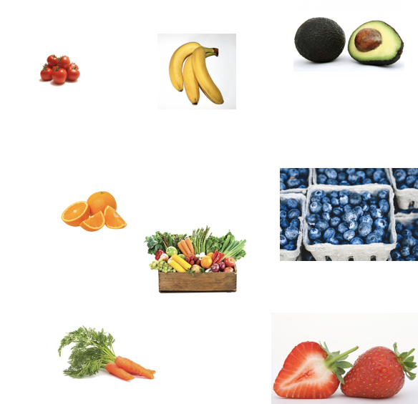

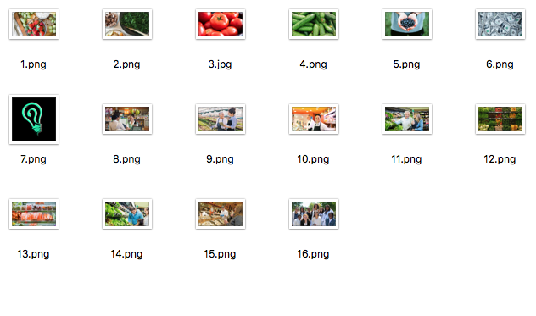

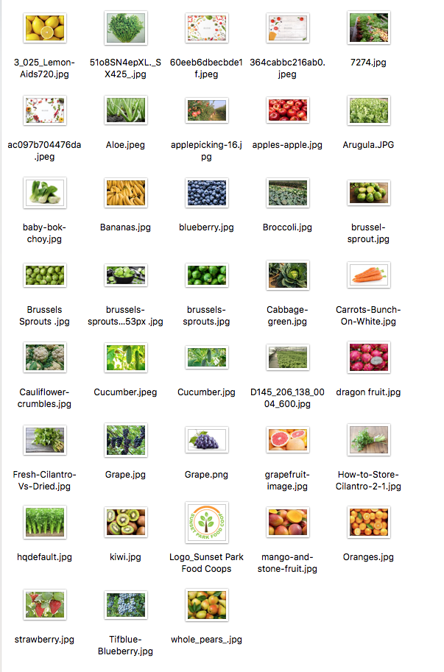

## Screenshots of all material created

Sunset Park Food Coop Logo Design (Dimi Wu)

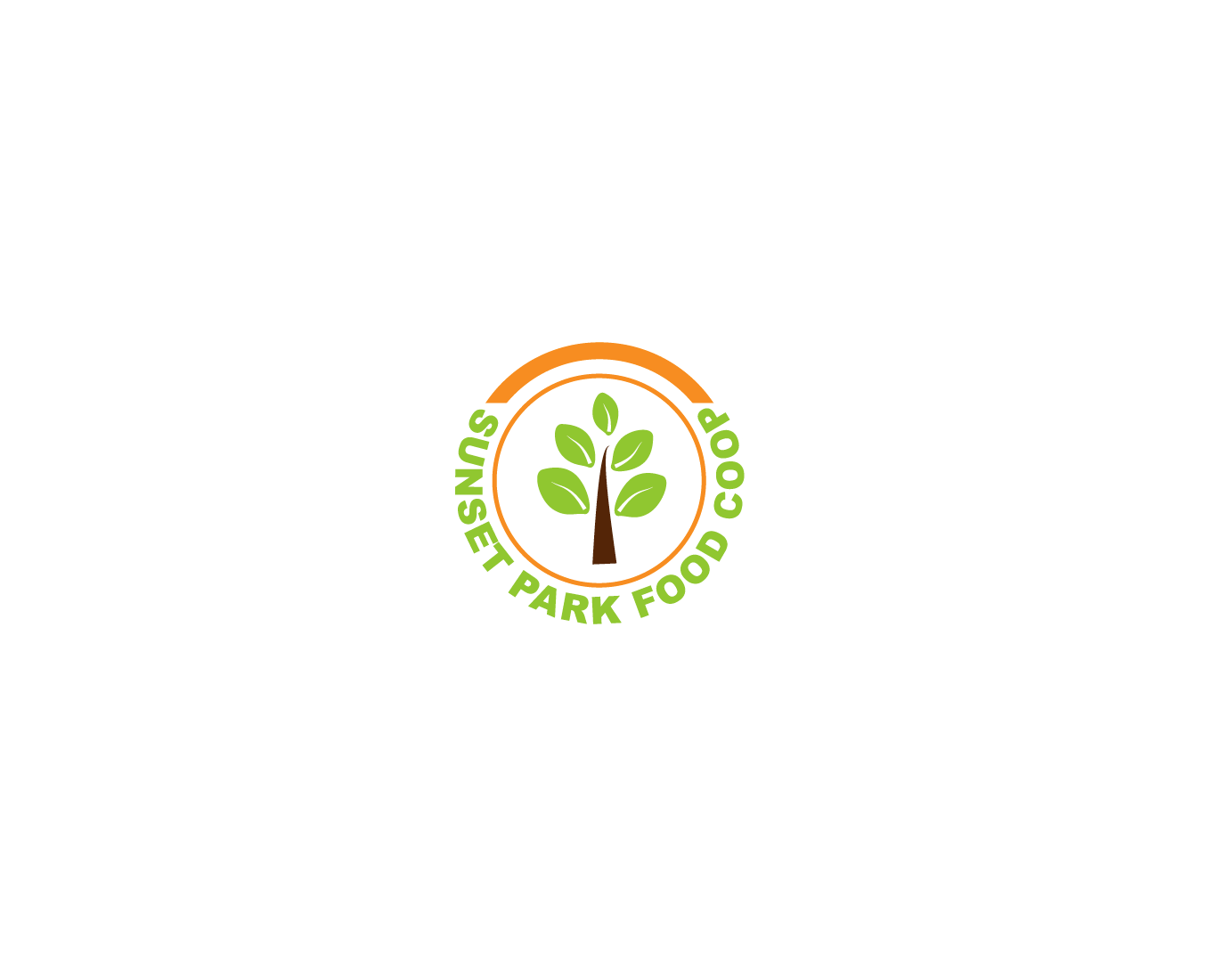

Sunset Park Food Coop Launch Video (Dimi Wu)



Sunset Park Food Coop Campaign Video (Dimi Wu)

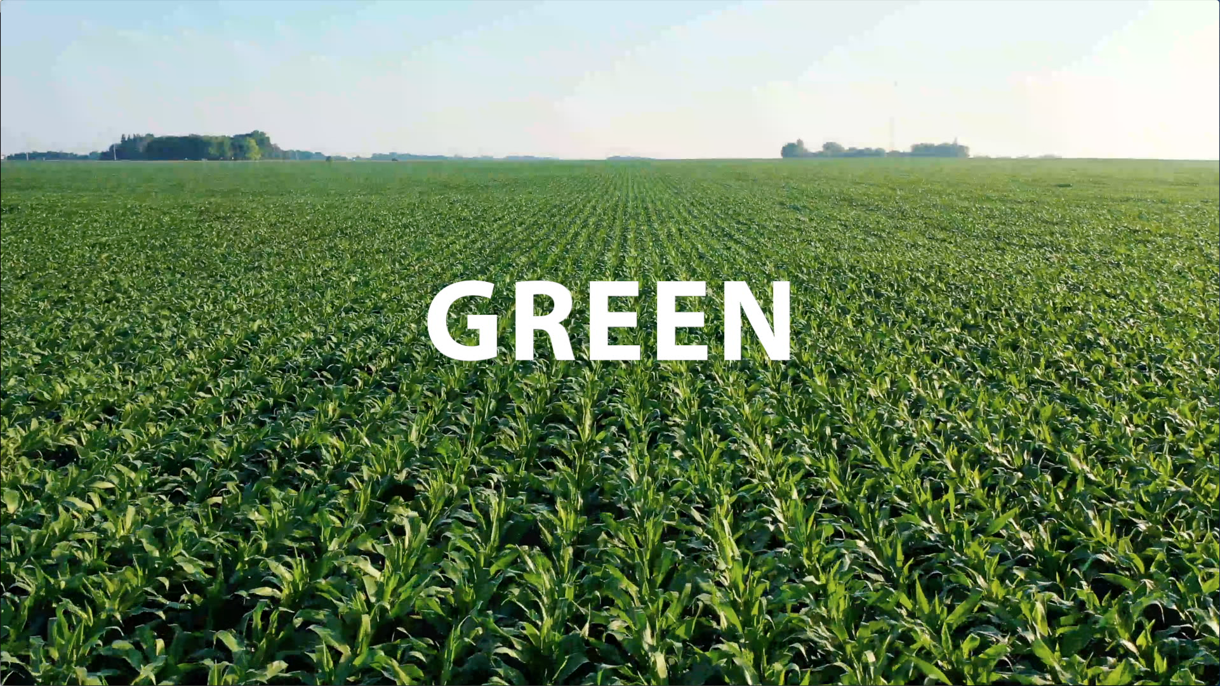

Sunset Park food Coop Campaign Animation (Dimi Wu)



Sunset Park Food Coop Logo Animation (Dimi Wu)



Sunset Park Food Coop Facebook Page (Dimi Wu)

<https://www.facebook.com/sunsetpark.foodcoops.3>

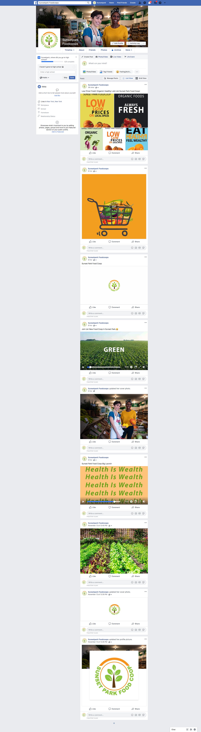

Sunset Park Food Coop Website (Ziwei Xing)

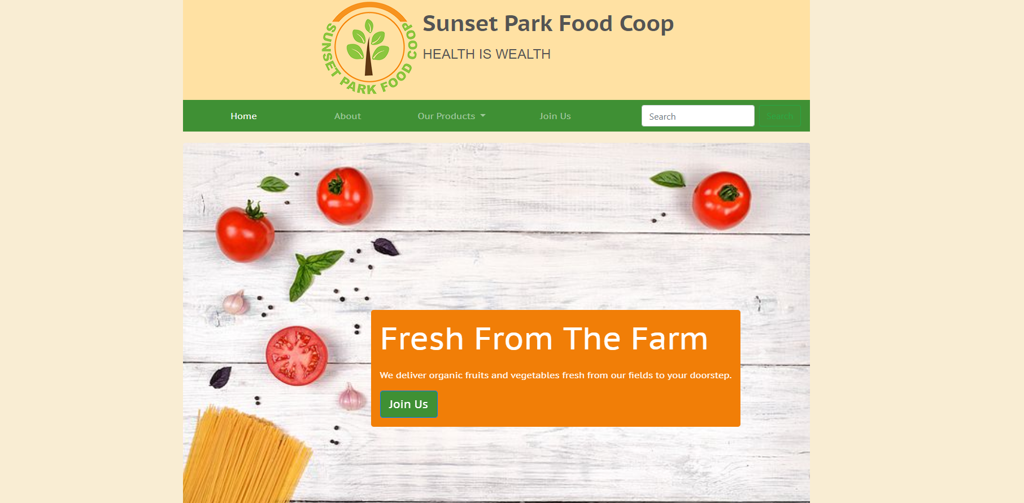

Top of Form

